NEWS RELEASE

SILVER TIGER INTERSECTS 4,461.4 g/t AgEq OVER 0.5 METERS IN THE SOOY VEIN

- 4th Drill Rig Commences Drilling at El Tigre and 5th Drill Rig Being Mobilized

HALIFAX, NOVA SCOTIA – June 29, 2021 – Silver Tiger Metals Inc. (TSXV:SLVR and OTCQX:SLVTF) ("Silver Tiger" or the “Corporation”) has intersected 0.5 meters grading 4,461.4 g/t silver equivalent in the Sooy Vein in Drill Hole ET-21-233. This hole was collared on Section 3900N to intersect the Sooy Vein on Section 4050N, approximately 900 meters to the south along strike from discovery hole ET-20-202 (see Silver Tiger press release dated Feb. 2, 2021).

Highlights from the on-going drilling program targeting the Sooy Vein include the following:

- Hole ET 21-233: 0.5 meters grading 4,461.4 g/t silver equivalent from 274.0 meters to 274.5 meters, consisting of 4,048.0 g/t silver, 0.45 g/t gold, 1.31% copper, 0.56% lead and 7.27% zinc, within 1.0 meter grading 2,270.8 g/t silver equivalent from 274.0 meters to 275.0 meters, consisting of 2,041.4 g/t silver, 0.25 g/t gold, 0.65% copper, 1.18% lead and 3.63% zinc.

- Hole ET-21-230: 0.5 meters grading 1,175.7 g/t silver equivalent from 239.2 meters to 239.7 meters consisting of 1,080.0 g/t silver, 0.20 g/t gold, 0.55% copper, 0.13% lead and 0.75% zinc, and 0.5 meters grading 1,175.7 g/t silver equivalent from 239.2 meters to 239.7 meters consisting of 1,080.0 g/t silver, 0.2 g/t gold, 0.55% copper, 0.13% lead and 0.75% zinc.

- Hole ET-21-229: 9.9 meters grading 208.7 g/t silver equivalent from 415.9 meters to 425.8 meters consisting of 83.3 g/t silver, 0.11 g/t gold, 0.27% copper, 1.01% lead and 2.04% zinc, including 1.8 meters grading 542.0 g/t silver equivalent from 424.0 meters to 425.8 meters consisting of 113.5 g/t silver, 0.21 g/t gold, 0.38% copper, 3.67% lead and 8.73% zinc.

Additional results are presented in the Drill Hole Results table below along with the details for the calculation of the silver equivalent grades.

See attached El Tigre Cross Section 4050N detailing drill hole ET-21-233. A Plan Map of El Tigre Veins and Drill Holes is also attached.

Silver Tiger’s CEO, Glenn Jessome, stated, “I am pleased that our technical team now has an additional 4th drill rig turning at El Tigre and a 5th drill rig is being mobilized to the property. Our wide-spaced reconnaissance drilling over 3 kilometers of strike from the Benjamin Vein (aka the “northern Sooy Vein”) south of Discovery Hole 202 on the Sooy has focused our attention on evolving high-grade ore shoots along strike. Our next phase of drilling will help define what we believe will become the basis for our next resource update.”

As previously reported, Discovery Drill Hole ET-20-202 intersected 11.75 meters grading 667.9 g/t silver equivalent within 22.2 meters grading 381.9 g/t silver equivalent approximately 12 meters beyond the footwall of the Sooy Vein. Drill Hole 202 was drilled to test the down dip potential of the Sooy Vein targeting just under the lowest mine level approximately 150 meters from surface where mining ceased abruptly with the onset of the Great Depression in 1930. Drill Hole 202 passed through mine workings on the Sooy Vein as it was not targeted deep enough below the workings. The technical team opted to continue
drilling beyond the footwall of the Sooy Vein and discovered a new style of wide high grade mineralization

in the Flat Formation that is not the traditional quartz vein ore that had been previously mined at El Tigre (refer to Silver Tiger press release dated February 2, 2021).

Drill Hole Results Table

Hole ID | Comment | From | To | Length⁽¹⁾ | Gold | Silver | Copper | Lead | Zinc | AgEq Total ⁽²⁾
 |  | m | m | m | g/t | g/t | % | % | % | g/t
ET-21-222 | Sooy Vein | 212.9 | 214.7 | 1.8 | 0.04 | 58.0 | 0.01 | 0.04 | 0.04 | 64.2
ET-21-224 |  | 189.5 | 192.5 | 3.0 | 0.04 | 29.9 | 0.01 | 0.00 | 0.01 | 33.9
ET-21-226 |  | 341.6 | 347.7 | 6.1 | 0.39 | 15.0 | 0.05 | 0.04 | 0.10 | 52.9
 | Sooy Vein | 378.2 | 387.4 | 9.2 | 0.08 | 27.1 | 0.10 | 0.08 | 0.10 | 48.2
ET-21-228 |  | 65.1 | 66.7 | 1.6 | 0.12 | 57.5 | 0.01 | 0.01 | 0.01 | 67.5
 |  | 113.5 | 114.5 | 1.0 | 0.04 | 61.1 | 0.01 | 0.00 | 0.00 | 64.5
 |  | 222.5 | 225.5 | 3.0 | 0.12 | 153.7 | 0.04 | 0.01 | 0.02 | 167.8
 |  | 265.0 | 271.4 | 6.4 | 0.21 | 30.5 | 0.01 | 0.06 | 0.05 | 49.7
 | Mining void El Tigre | 281.5 | 289.4 | 7.9 | - | - | - | - | - | -
ET-21-229 | Sooy Vein | 416.0 | 429.5 | 13.5 | 0.13 | 63.4 | 0.21 | 0.78 | 1.60 | 164.6
 | including | 416.0 | 425.9 | 9.9 | 0.11 | 83.3 | 0.27 | 1.01 | 2.04 | 208.7
 | including | 424.0 | 425.8 | 1.8 | 0.21 | 113.5 | 0.38 | 3.67 | 8.73 | 542.0
ET-21-230 |  | 134.8 | 137.8 | 3.0 | 0.21 | 32.9 | 0.01 | 0.01 | 0.00 | 49.8
 |  | 153.7 | 155.5 | 1.8 | 0.05 | 87.0 | 0.03 | 0.00 | 0.01 | 94.2
 |  | 189.0 | 189.5 | 0.5 | 0.15 | 704.0 | 0.14 | 0.00 | 0.05 | 731.1
 |  | 211.5 | 214.5 | 3.0 | 0.04 | 76.2 | 0.02 | 0.01 | 0.03 | 82.1
 |  | 228.2 | 230.2 | 2.0 | 0.07 | 82.1 | 0.02 | 0.01 | 0.02 | 89.4
 |  | 239.2 | 242.2 | 3.0 | 0.12 | 193.3 | 0.09 | 0.03 | 0.15 | 216.9
 | including | 239.2 | 239.7 | 0.5 | 0.20 | 1,080.0 | 0.55 | 0.13 | 0.75 | 1,175.7
 |  | 267.6 | 268.1 | 0.5 | 0.28 | 199.0 | 0.06 | 0.20 | 0.34 | 241.5
 |  | 285.5 | 288.5 | 3.0 | 0.21 | 43.4 | 0.02 | 0.05 | 0.06 | 63.9
 |  | 330.2 | 330.7 | 0.5 | 0.41 | 161.0 | 0.04 | 0.19 | 0.44 | 214.4
ET-21-231 | pending
ET-21-232 |  | 234.5 | 236.5 | 2.0 | 0.05 | 60.8 | 0.03 | 0.03 | 0.02 | 68.9
 |  | 347.7 | 349.0 | 1.3 | 0.16 | 32.0 | 0.22 | 1.45 | 1.36 | 143.9
 | Mining void Sooy Vein | 355.7 | 358.4 | 2.7 | - | - | - | - | - | -
 |  | 384.3 | 387.4 | 3.1 | 0.26 | 46.0 | 0.02 | 0.10 | 0.04 | 70.6

Hole ID | Comment | From | To | Length⁽¹⁾ | Gold | Silver | Copper | Lead | Zinc | AgEq Total ⁽²⁾
 |  | m | m | m | g/t | g/t | % | % | % | g/t
ET-21-233 |  | 244.5 | 245.0 | 0.5 | 0.13 | 491.0 | 0.08 | 0.01 | 0.03 | 509.7
 | Sooy Vein | 274.0 | 275.0 | 1.0 | 0.25 | 2,041.4 | 0.65 | 1.18 | 3.63 | 2,270.8
 | including | 274.0 | 274.5 | 0.5 | 0.45 | 4,048.0 | 1.31 | 0.56 | 7.27 | 4,461.4
 |  | 350.6 | 351.5 | 0.9 | 0.25 | 171.0 | 0.10 | 0.50 | 0.91 | 241.3
 | El Tigre Vein | 362.9 | 377.5 | 14.6 | 0.17 | 56.7 | 0.02 | 0.00 | 0.03 | 73.1
 | including | 363.4 | 364.0 | 0.6 | 0.11 | 380.0 | 0.08 | 0.22 | 0.04 | 402.2
 | Seitz Kelly Vein | 447.1 | 455.1 | 8.0 | 0.04 | 72.8 | 0.02 | 0.05 | 0.12 | 83.3
 | including | 449.1 | 450.1 | 1.0 | 0.08 | 200.0 | 0.06 | 0.00 | 0.20 | 218.6
ET-21-234 |  | 152.9 | 155.1 | 2.2 | 0.07 | 59.6 | 0.02 | 0.11 | 0.16 | 75.0

Notes: 1. Not true width.
2. Silver Equivalent (“EqAg”) ratios are based on a silver to gold price ratio of 75:1 (Au:Ag). Copper, lead and zinc are
converted using $3.66/lb copper, $0.90/lb lead, $1.26/lb zinc at 100% metal recoveries based on a silver price of
$26.00/oz.

Drill Hole Location Table

Hole ID | Section | Easting | Northing | Elevation | Az | Dip | Length
ET-21-222 | 4575N | 670681 | 3384574 | 1935 | 93 | -53 | 308.1
ET-21-224 | 4425N | 670682 | 3384423 | 1952 | 88 | -67 | 332.5
ET-21-226 | 4425N | 670682 | 3384423 | 1952 | 88 | -56 | 466.7
ET-21-228 | 3815N | 670911 | 3383816 | 1832 | 60 | -30 | 289.4
ET-21-229 | 4475N | 670707 | 3384475 | 1945 | 90 | -64 | 472.8
ET-21-230 | 3825N | 670883 | 3383820 | 1818 | 60 | -38 | 372.1
ET-21-231 | 4425N | 670682 | 3384423 | 1952 | 88 | -50 | 216.6
ET-21-232 | 4475N | 670707 | 3384475 | 1945 | 90 | -58 | 430.1
ET-21-233 | 3900N | 670848 | 3383899 | 1816 | 50 | -35 | 460.6
ET-21-234 | 4925N | 670737 | 3384920 | 1861 | 90 | -50 | 387.4

El Tigre Cross Section 4050N
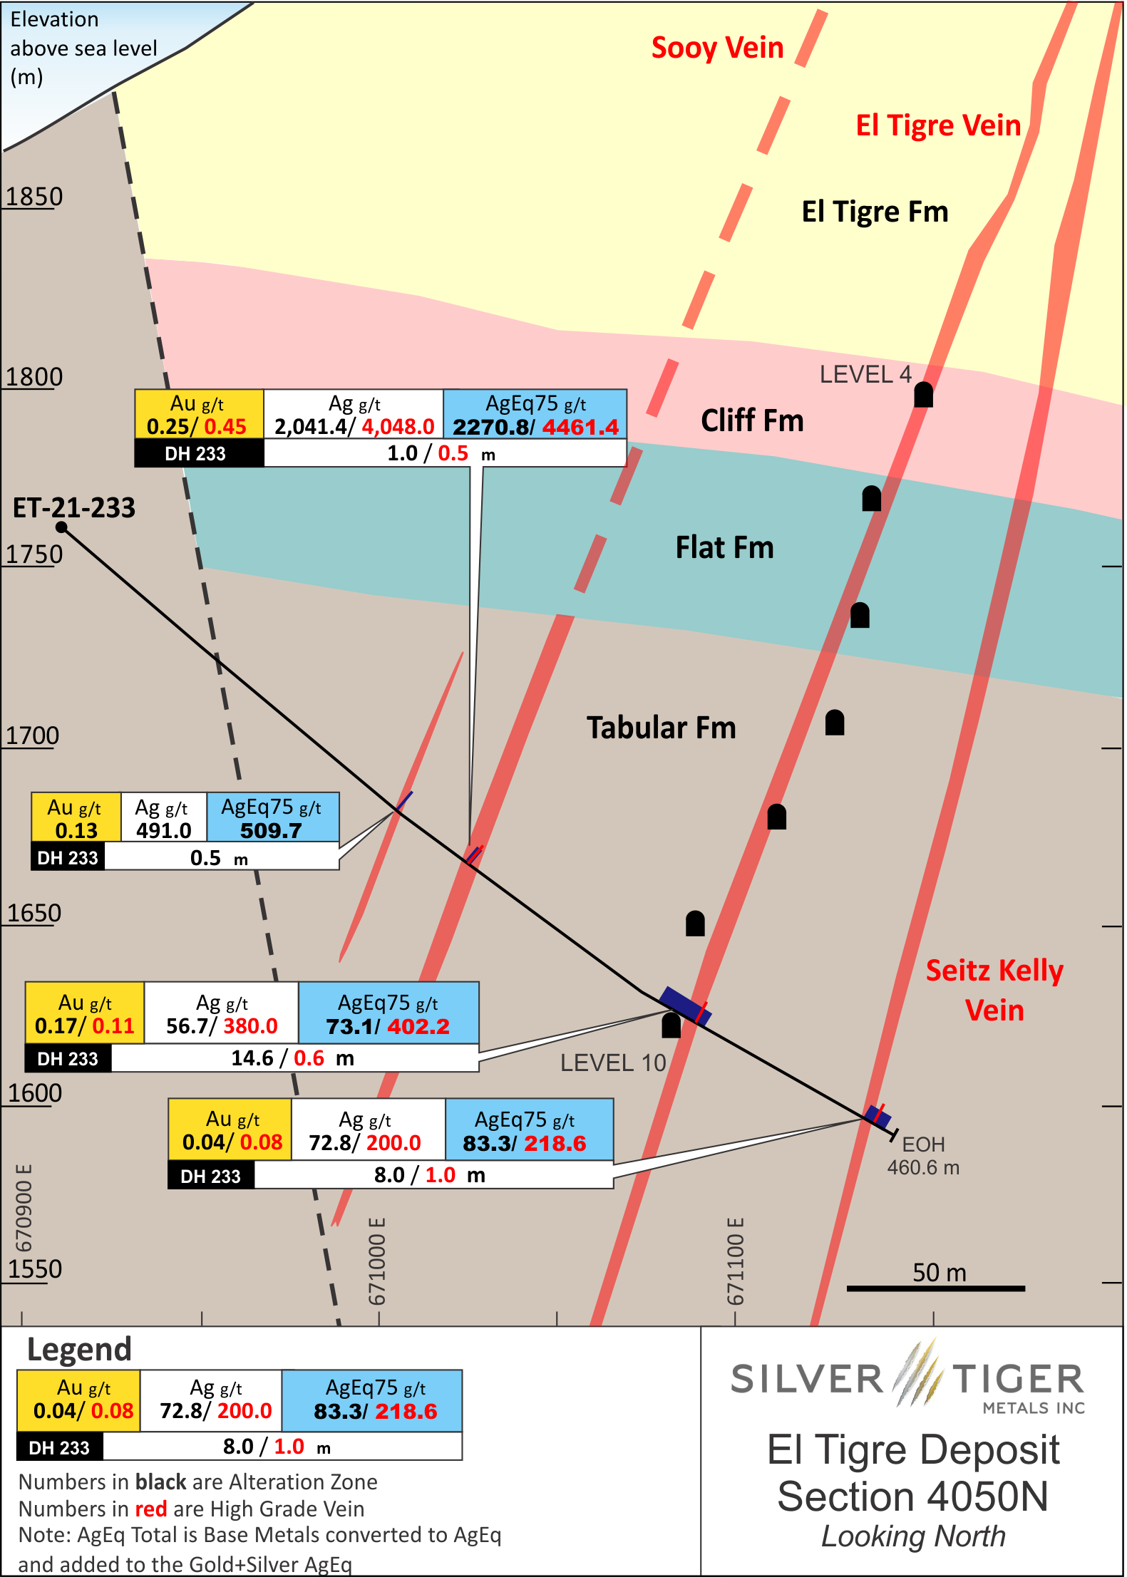
Plan Map of the El Tigre Veins and Drill Holes
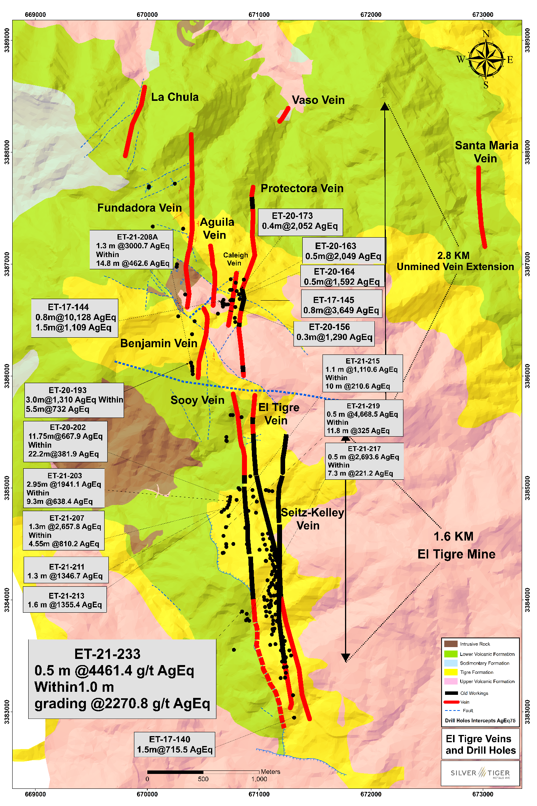

El Tigre Resource Estimate

After acquiring El Tigre, Silver Tiger drilled 12,500 meters to define the wide halo of near surface gold mineralization around the mined high-grade veins of the historic El Tigre Mine. This allowed Silver Tiger to deliver a maiden resource estimate for the El Tigre Property to a depth of 150 meters containing indicated resources of 661,000 gold equivalent ounces at 0.77 g/t (21 g/t silver and 0.51 g/t gold) and inferred resources of 341,000 gold equivalent ounces at 1.59 g/t (88 g/t silver and 0.52 g/t gold). The National Instrument 43-101 Technical Report titled “NI 43-101 Technical Report and Updated Mineral Resource Estimate on the El Tigre Project, Sonora, México” effective as of September 7, 2017 and dated October 26, 2017 prepared by David Burga, P.Geo., Yungang Wu, P.Geo., Fred Brown, P.Geo., Jarita Barry, P.Geo., Eugene Puritch, P.Eng., FEC, CET, Alfred Hayden, P.Eng. and Richard H. Sutcliffe, Ph.D., P.Geo. of P&E Mining Consultants Inc. is available on the Corporation’s website at www.silvertigermetals.com and on www.sedar.com under the Corporation’s profile.

About the El Tigre Historic Mine District

Silver Tiger Metals Inc. is a Canadian company whose management has more than 25 years’ experience discovering, financing and building large hydrothermal silver projects in Mexico. Silver Tiger’s 100% owned 28,414 hectare Historic El Tigre Mining District is located in Sonora, Mexico. Principled environmental, social and governance practices are core priorities at Silver Tiger.

The El Tigre historic mine district is located in Sonora, Mexico and lies at the northern end of the Sierra Madre silver and gold belt which hosts many epithermal silver and gold deposits, including Dolores, Santa Elena and Las Chispas at the northern end. In 1896, gold was first discovered on the property in the Gold Hill area and mining started with the Brown Shaft in 1903. The focus soon changed to mining high-grade silver veins in the area with production coming from 3 parallel veins the El Tigre Vein, the Seitz Kelley Vein and the Sooy Vein. Underground mining on the middle El Tigre vein extended 1,450 meters along strike and was mined on 14 levels to a depth of approximately 450 meters. The Seitz Kelley Vein was mined along strike for 1 kilometer to a depth of approximately 200 meters. The Sooy Vein was only mined along strike for 250 meters to a depth of approximately 150 meters. Mining abruptly stopped on all 3 of these veins when the price of silver collapsed to less than 20¢ per ounce with the onset of the Great Depression. By the time the mine closed in 1930, it is reported to have produced a total of 353,000 ounces of gold and 67.4 million ounces of silver from 1.87 million tons (Craig, 2012). The average grade mined during this period was over 2 kilograms silver equivalent per ton.

The El Tigre silver and gold deposit is related to a series of high-grade epithermal veins controlled by a north-south trending structure cutting across the andesitic and rhyolitic tuffs of the Sierra Madre Volcanic Complex within a broad silver and gold mineralized prophylitic alteration zone developed in the El Tigre Formation that can be up to 150 meters wide. The veins dip steeply to the west and are typically 0.5 meter wide but locally can be up to 5 meters in width. The veins, structures and mineralized zones outcrop on surface and have been traced for 5.3 kilometers along strike in our brownfield exploration area. Historical mining and exploration activities focused on a 1.5 kilometer portion of the southern end of the deposits, principally on the El Tigre, Seitz Kelly and Sooy veins. The under explored Caleigh, Benjamin, Protectora and the Fundadora exposed veins continue north for more than 3 kilometers. Silver Tiger has delivered its maiden 43-101 compliant resource estimate and is currently drilling to update its resource estimate and publish a PEA.

VRIFY Slide Deck and 3D Presentation – Silver Tiger’s El Tigre Project

VRIFY is a platform being used by companies to communicate with investors using 360° virtual tours of remote mining assets, 3D models and interactive presentations. VRIFY can be accessed by website and with the VRIFY iOS and Android apps.

Access the Silver Tiger Metals Inc. Company Profile on VRIFY at: https://vrify.com

The VRIFY Slide Deck and 3D Presentation for Silver Tiger Metals Inc. can be viewed at: https://vrify.com/explore/decks/492 and on the Company’s website at: www.silvertigermetals.com.

Procedure, Quality Assurance / Quality Control and Data Verification

The diamond drill core (HQ size) is geologically logged, photographed and marked for sampling. When the sample lengths are determined, the full core is sawn with a diamond blade core saw with one half of the core being bagged and tagged for assay. The remaining half portion is returned to the core trays for storage and/or for metallurgical test work.

The sealed and tagged sample bags are transported to the Bureau Veritas facility in Hermosillo, Mexico. Bureau Veritas crushes the samples (Code PRP70-250) and prepares 200-300 gram pulp samples with ninety percent passing Tyler 200 mesh (Code PUL85). The pulps are assayed for gold using a 30-gram charge by fire assay (Code FA630) and over limits greater than 10 grams per tonne are re-assayed using a gravimetric finish (Code FA530). Silver and multi-element analysis is completed using total digestion (Code MA200 Total Digestion ICP). Over limits greater than 100 grams per tonne silver are re-assayed using a gravimetric finish (Code FA530).

Quality assurance and quality control ("QA/QC") procedures monitor the chain-of-custody of the samples and includes the systematic insertion and monitoring of appropriate reference materials (certified standards, blanks and duplicates) into the sample strings. The results of the assaying of the QA/QC material included in each batch are tracked to ensure the integrity of the assay data. All results stated in this announcement have passed Silver Tiger’s QA/QC protocols.

Qualified Person

David R. Duncan, P. Geo., V.P. Exploration of the Corporation, is the Qualified Person for Silver Tiger as defined under National Instrument 43-101. Mr. Duncan has reviewed and approved the scientific and technical information in this press release.

For further information, please contact:

Glenn Jessome
President and CEO
902 492 0298
jessome@silvertigermetals.com
CAUTIONARY STATEMENT:
Neither TSX Venture Exchange nor its Regulation Services Provider (as that term is defined in the policies of the TSX Venture Exchange) accepts responsibility for the adequacy or accuracy of this release.
This News Release includes certain “forward-looking statements”. All statements other than statements of historical fact included in this release, including, without limitation, statements regarding potential mineralization, resources and reserves, the ability to convert inferred resources to indicated resources, the ability to complete future drilling programs and infill sampling, the ability to extend resource blocks, the similarity of mineralization at El Tigre to Delores, Santa Elena and Chispas, exploration results, and future plans and objectives of Silver Tiger, are forward-looking statements that involve various risks and uncertainties. Forward-looking statements are frequently characterized by words such as “may”, “is expected to”, “anticipates”, “estimates”, “intends”, “plans”, “projection”, “could”, “vision”, “goals”, “objective” and “outlook” and other similar words. Although Silver Tiger believes the expectations expressed in such forward-looking statements are based on reasonable assumptions, there can be no assurance that such statements will prove to be accurate and actual results and future events could differ materially from those anticipated in such statements. Important factors that could cause actual results to differ materially from Silver Tiger’s expectations include risks and uncertainties related to exploration, development, operations, commodity prices and global financial volatility, risk and uncertainties of operating in a foreign jurisdiction as well as additional risks described from time to time in the filings made by Silver Tiger with securities regulators.

